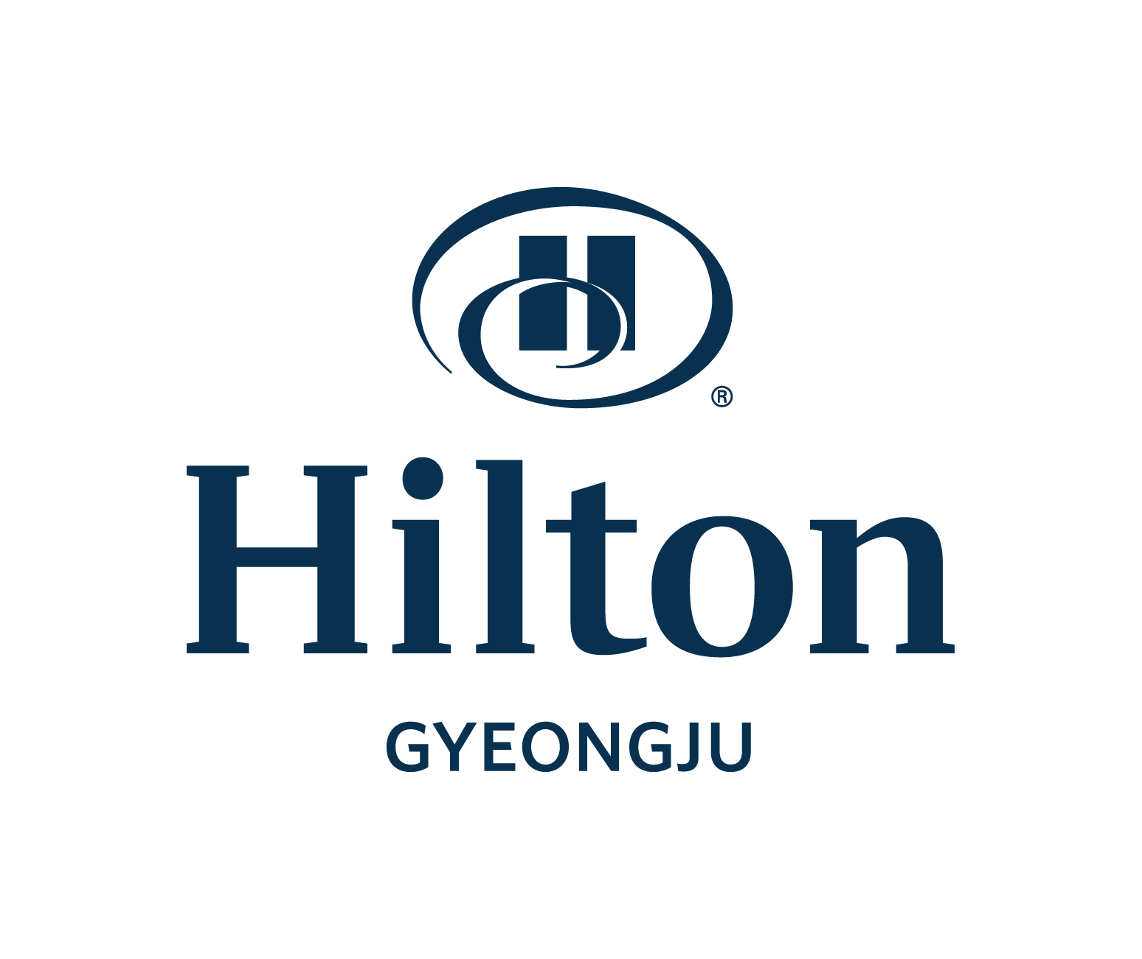
Hotel Reservation Form
8th ICLPRP 2023 [Oct 22~27. 2023]

August 25 ~ 27, 2009
Please complete this form with all requested information and send it to the hotel directly by e-mail or fax.
E-mail: donghyo.seo@hilton.com/Reservation Manager Fax: +82-54-745-7799, Phone: +82-54-740-1232~4
Please check-out reservation number after sending reservation form.

Participant Information
First Name: Last Name: Title: □Mr. □Ms.
Company Name : Position:
Sharing Room with First Name(Optional): Last Name:
Phone: Fax: E-mail:
Arrival Date : Departure Date: No. of Nights:
Special request and comments :
Non smoking : All Rooms (Not available Smoking room)

Accommodation Information
Room Type | Rate | Remark
Single or Twin room (Sun~Thu) | □ KRW 190,000 | Room only rate
Breakfast Buffet | □ KRW 38,000 Per Person | Lakeside (06:30~ 10:00)
* All rates are including 10% Tax.
* No later than Oct 06. 2023 to ensure room availability and group rate.
* When an available room on Friday & Saturday nights, should be charged W60,000 & W120,000 more than above special rate
* Check-in time: 15:00 PM, Check-out time: 11:00 AM

Payment Information
In order to guarantee your reservation, your credit card information must be accompanied.
□ AMEX □ VISA □ Master □ Dinners □ JCB □ Other( )
Card No.: Expiration Date(mm/yy)
Cardholder’s Name: Date: Signature:

Cancellation Policy
- If you cancel your reservation, please do so 5days prior to arrival to avoid cancellation penalties

♦ Confirmation
예약번호 |  | 담당자 | Myung-Soo. Jeon: 010 2688 5986

